Kelsey McHolm- 214681936

Writ 3001: Intermediate Digital Authorizing: Hand-coded web design project

April 7th, 2022

Professor Rich Shivener

Assignment 3- Post-Mortem Document

**Introduction**

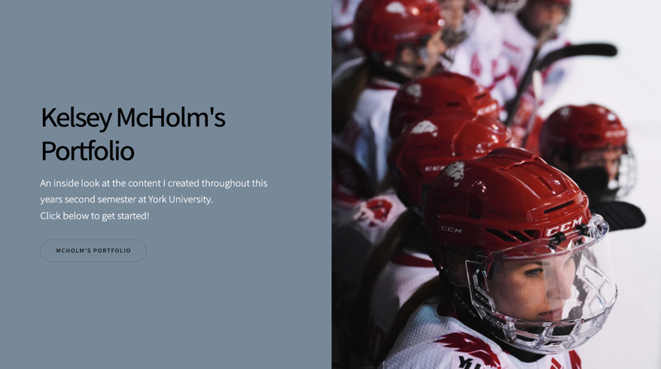This hand-coded web design assignment was one that tested not only my patience but a skill I never thought I was going to learn. During the last three to four weeks, I was pushed outside of my comfort zone to modify a template into something that I could call my own. This semester allowed me to show case my skills as a writer and a creator and display them on a platform that I personally edited all by myself. Some of the technical choices seen in my web design is the use of embedding sound, video, images and dialogue as a means for content on the page. I created a web design that starts off with who I am as a writer and what the web page entails and working down toward the content that backs up the story I am telling. By changing fonts, background colors, usage of buttons, charts and more, I was able to remix a template to become my own. Rhetorically, I made this web page similar to a story bored. I was able to share and express my passion for social media and online platforms through creating my own online platform.

**What Went Right**

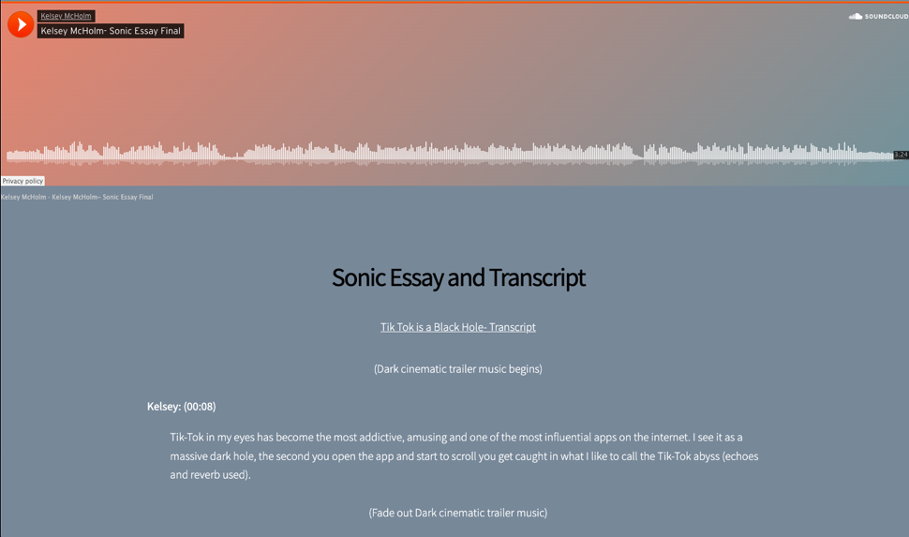 The overall vision I had when creating this web design was to create a page that mimicked the look of a story board. This idea stemmed because writing, social media, and the creation of short 30 to 60 second videos all produce some type of story that has a beginning, a middle and an end. That is exactly what I did on the web page. This story board was created back in January when I came up with the initial idea behind Tik Tok being an app that is like a black hole, once you are caught in it, there is no way of getting out. From there I created a story using my voice and other sounds and then applied that file to create a story using visuals. This then allowed me to create a page to share the way that Tik Tok is one of the most addicting platforms on the internet.

**What Went Wrong**

I hate to say everything, but in the last final weeks of creating this web design project, I lost all of the content. My device that I was working on had a backup and I sadly lost my on-going project that I was working on over the last three weeks. Luckily, my video essay and sonic essay were all on a different computer drive. I think the struggle I had wasn’t so much about starting over but rather, remembering the steps on how to begin. Although I was originally sad, mad an frustrated over this project not being save, I think my new website turned out better than my old one started. Another thing I found difficult was the process of making the template my own. I think it is very easy to copy and paste links and paragraphs of writing into where the old writing and content was but, trying to figure out how to change colors, fonts, backgrounds and images was super difficult due to the needs to add different codes to make your vision come to life.

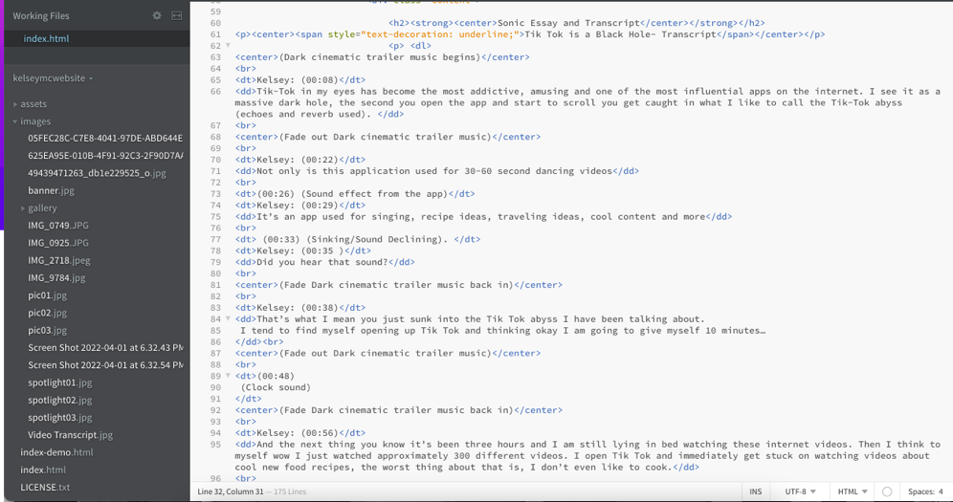(I don’t have any images of my lost files)